EGERTON UNIVERSITY

software design document (SDD)
for

Title: hospital referral management system

prepared by: Students name: okola cetric
reg. no.: s13/09717/15

project supervisor: mr. katiku jones

project cordinator: dr. w. gikaru

dates:18/4/2019

version: 1.0
Overview
The System Design Document describes the system requirements, operating environment, system and subsystem architecture, files and database design, input formats, output layouts, human-machine interfaces, detailed design, processing logic, and external interfaces.

Table of Contents
1 INTRODUCTION 3
1.1 Purpose and Scope 3
1.2 Project Executive Summary 3
1.2.1 System Overview 3
1.2.2 Design Constraints 3
1.2.3 Future Contingencies 3
1.3 Document Organization 3
1.4 Points of Contact 3
1.5 Project References 4
1.6 Glossary 4
2 SYSTEM ARCHITECTURE 4
2.1 System Hardware Architecture 4
2.2 System Software Architecture 4
2.3 Internal Communications Architecture 4
3 FILE AND DATABASE DESIGN 4
3.1 Database Management System Files 5
3.2 Non-Database Management System Files 5
4 HUMAN-MACHINE INTERFACE 5
4.1 Inputs 6
4.2 Outputs 6
5 DETAILED DESIGN 6
5.1 Hardware Detailed Design 7
5.2 Software Detailed Design 7
5.3 Internal Communications Detailed Design 8
6 EXTERNAL INTERFACES 8
6.1 Interface Architecture 8
6.2 Interface Detailed Design 9
7 SYSTEM INTEGRITY CONTROLS 9

INTRODUCTION

Purpose and Scope
This section provides a brief description of the Systems Design Document’s purpose and scope. The System Design Document describes the system requirements, operating environment, system and subsystem architecture, files and database design, input formats, output layouts, human-machine interfaces, detailed design, processing logic, and external interfaces.

Project Executive Summary
This section provides a description of the project from a management perspective and an overview of the framework within which the conceptual system design was prepared.

System Overview
The hospital management system’s main function is to enable referral of patient from one to another hospital facility having the service the patient requires. This system is supposed to be used by patients, doctors’ nurses of various hospitals and the hospital admins. The patients are required to create an account where they will be using to access the system when they want to view their medical history and the referral status. The doctors and the nurses their work is to update the medical report of their patients and refer the patient to the other medical facilities with the services the patient requires. The hospital admin creates a hospital profile, register the doctors and the nurses under that facility and add the services to the facility. The system also enables the admin to view the present referrals to the facility.
The system architecture is as below:
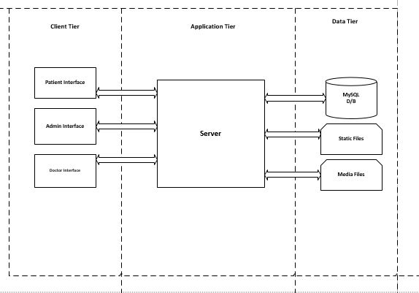

Design Constraints
This section describes any constraints in the system design. All the data is to be stored in a relational database with a client server architecture. The hospital license code should be provided at the facility creation stage and needs to be verified with the hospital registration system of different states. HRM is to be developed only in English hence can only be used in states with English as their native or official language or national language.

Future Contingencies
Blockchain technology is proposed to be used to store patient data. Insurance verification of patients who are covered prior to the referral.

Document Organization
This document has sections that tackle various design stages of the system. Its summary is the references, glossary, design considerations, data design with class and table structures, system architecture with components and user interface designs. Apart from these main parts, it also states and describes the tools that will be used during implementation of this system
Chapter | Topic | Description
1 | Introduction | Introduces what is going to be discussed in the whole document
2 | System Architecture | Describes the system and/or subsystem architecture for the project.
3 | File and Database Design | Shows the final design of the database, ER-Diagrams and Relational Diagram with all the entities
4 | Human Machine Interface | Shows the detailed design including input and output interfaces of the system and subsystem.
5 | Detailed Design | Data that is necessary for system implementation
6 | External Interface Design | Describes how the system will connect with other systems.
7 | Integrity Control

Points of Contact
This system is built for Egerton University. The Project Manager, System Proponent, User Organization, Quality Assurance (QA) Manager, Security Manager, and Configuration Manager is Cetric Okola S13/09717/15. The phone number is 0704145832 and the email address is okolacetric@gmail.com.

Project References
Team leader, Joan, Paul Adams, Bobbie Baker, Charlie Charles. Web Publishing System, Software Design Document. Jacksonville State University, 2004.

Glossary
Referral: -process of transferring a patient from one hospital to another.
Facility: -required equipment or hospital infrastructure
HRM: - Hospital Referral Management.
SDD: - System Design Document.
UML: - Unified Modelling Language.
RDBMS: -Relational Database Management System.

SYSTEM ARCHITECTURE
In this section, describe the system and/or subsystem(s) architecture for the project.

System Hardware Architecture
The hardware components required for the system to properly function is server connected to the internet backbone for hosting the application.
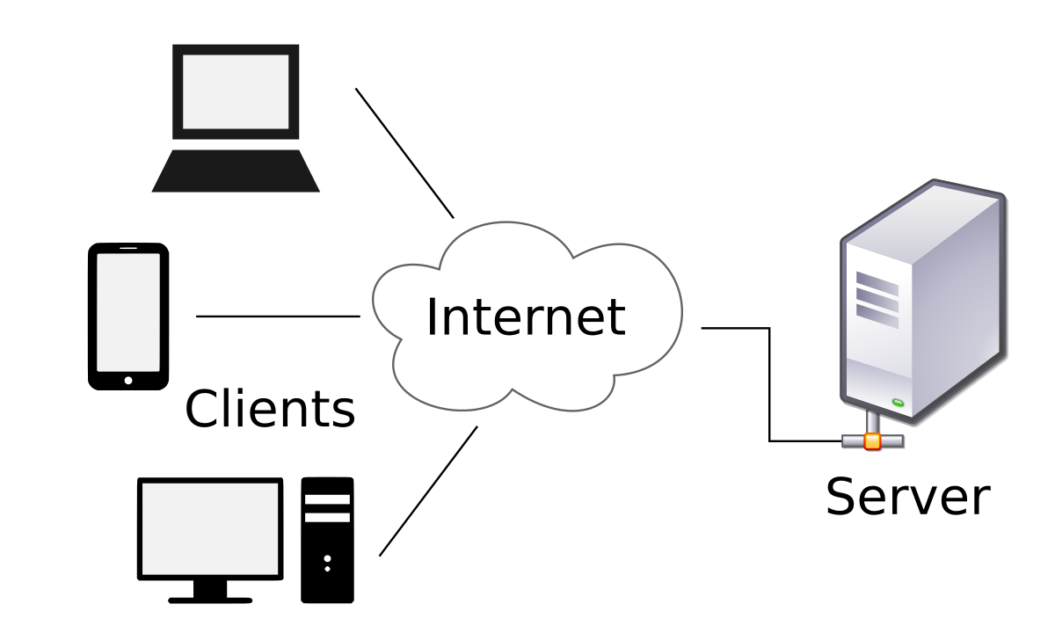

System Software Architecture
HRM is to be developed in Golang using Beego framework and the Microsoft visual studio code as the editor. UML is used to model the system. Diagrams to be used will include activity, class, sequence and use-case. MySQL is used as the RDBMS. The software modules include:

- Account creation: -Handles creation of user accounts for the system and the associated validation.
- Authentication: -Handles the authenticating users when logging into the system.
- Referral: - Handles the referral process
- Medical record management: -Deals with updating the medical records and displaying them to the required users.
- Facility management: - Handles the facility creation, service addition, update and deletion. staff addition and deletion.

Internal Communications Architecture
This system is to be accessed from port Localhost:8080

FILE AND DATABASE DESIGN

Database Management System Files

Normalized tables(3NF)
admin
id
email
password
employee
first_name
last_name
emp_id
code
employee_account
emp_id
email
phone_no
password
hospital_account
code
name
serial_no
phone_no
email
country
region
district
mgn_id

r_date

patient_account
first_name
last_name
huduma_no
do_b
phone_no

password
sex
patient_diagnosis
id
huduma_no

huduma_no
weight
temperature

blood_pressure
diagnosis
response
prescription
reg_date
service
service_code

code
cost
slot
department
referrals
id
huduma_no

service

hos_name
r_time

Database schema
admin_account (id, email, password)
employee (first_name, last_name, position, emp_id, code)
employee_account (emp_id, email, phone_no, password)
hospital_account (code, name, serial_no, phone_no, email, country, region, district, mgn_id)
patient_account (first_name, last_name, huduma_no, do_b, phone_no, password, sex)
patient_diagnosis (id, huduma_no, weight, temperature, blood_pressure, diagnosis, response, prescription, reg_date)
referrals (id, huduma_no, service, hos_name, r_date, r_time)
services (service_code, code, name, cost, slot, department)

The ER diagram

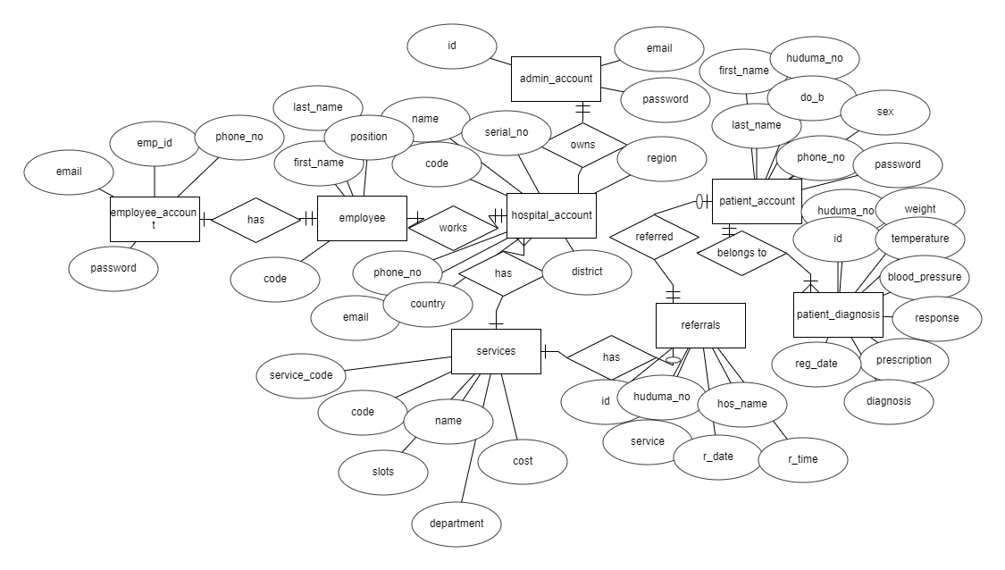

HUMAN-MACHINE INTERFACE
This section provides the detailed design of the system and subsystem inputs and outputs relative to the user/operator.

Inputs
This section is a description of the input media used by the operator for providing information to the system;
Authentication: - for one to access the system, password and huduma number for patient, employee id for staff and national id for admin should be provided.

Log in for patient.
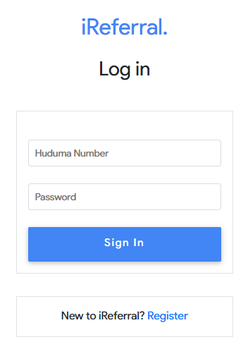
The log in screen for staff and admin resembles to the above screen.
Referral process: - the doctor or the nurse is required to input name of the hospital, referral date and time, the service the patient requires and the huduma number for the patient.
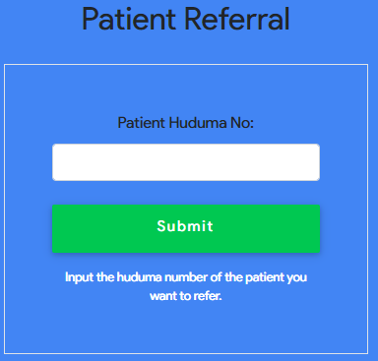
Medical record update: - the doctor is required to fill in a form with medical triage data (weight, temperature and the blood pressure). Diagnosis, prescription and response whose data type is text.
All the data inputs are in string form.
Selection of data inputs from the dropdown is also incorporated.
The error messages should be displayed after validated when the user inputs wrong data into the form.
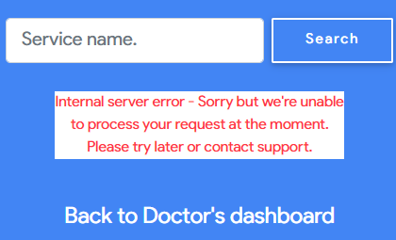

Outputs
Authentication: -Upon successful log in, the users should land to the home page, example doctors’ dashboard display his/her names.
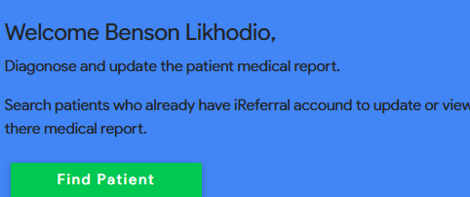
Referral: -Tables having the name of referral hospital, service name, patient huduma number.
Medical report management: -Medical triage details, diagnosis report, date and prescription should be included on the screen.

DETAILED DESIGN

Hardware Detailed Design

Software Detailed Design
HRM is divided into
- Authentication
- Medical records
- Referrals
- Facility management

Authentication.
It involves logging in and account creation. The three users access the system via the log in interface once they have created an account through the sign-up page. During account creation, the data detailed at the input section in chapter four is provided and submitted to the database. During log in, the password is retrieved from the accounts table and should match with the one the user has provided.
The account file in the controllers to handle the authentication. It has log in methods for patient, doctor and the admin. Account creation methods for both users. Sessions are also handled in the account file and finally log out methods for exiting the system and destroying the session of the user.

Medical records management.
This module is used by the doctor or the nurse and the patient. The work of the doctor is to update medical report of the patient and view the previous medical history. The patient is only required to view the medical history of his passed tests and diagnosis.
For the doctor or the nurse to update the medical report, he/she should enter the patient huduma number to find the patient. This should be handled by a file called doctor having the method for searching the patient. Once the patient is found, the diagnosis file should now handle the details of diagnosis and store to the table having the medical history.
When viewing the medical report, patient file has a method for retrieving medical values from the database and displaying it to the patient or the doctor.

Referrals
This module is handled by both users. It comprises of the actual referral process and viewing of the referral details. The doctor has to refer a patient by choosing the service, hospital name and date plus time and submit it to the database. This is to be handled by refer file having the list hospital methods. Viewing of the referrals is done by the admin view referral file.

Facility management
This module is only used by the hospital management user alias the admin. It involves facility profile creation, service registration, update and deletion, staff creation and deletion. This is handled by the facility management and hospital registration file. The two files all have the files necessary for the processes to be carried out.
the detailed module designs:
Use case
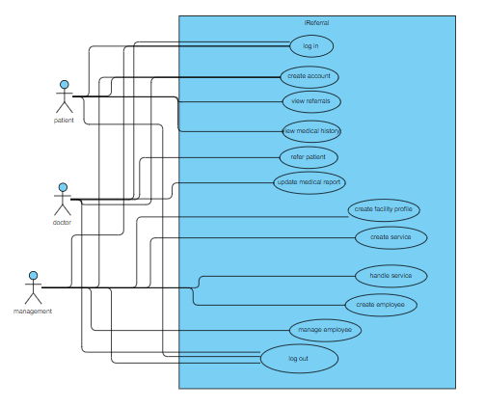

Flow chart
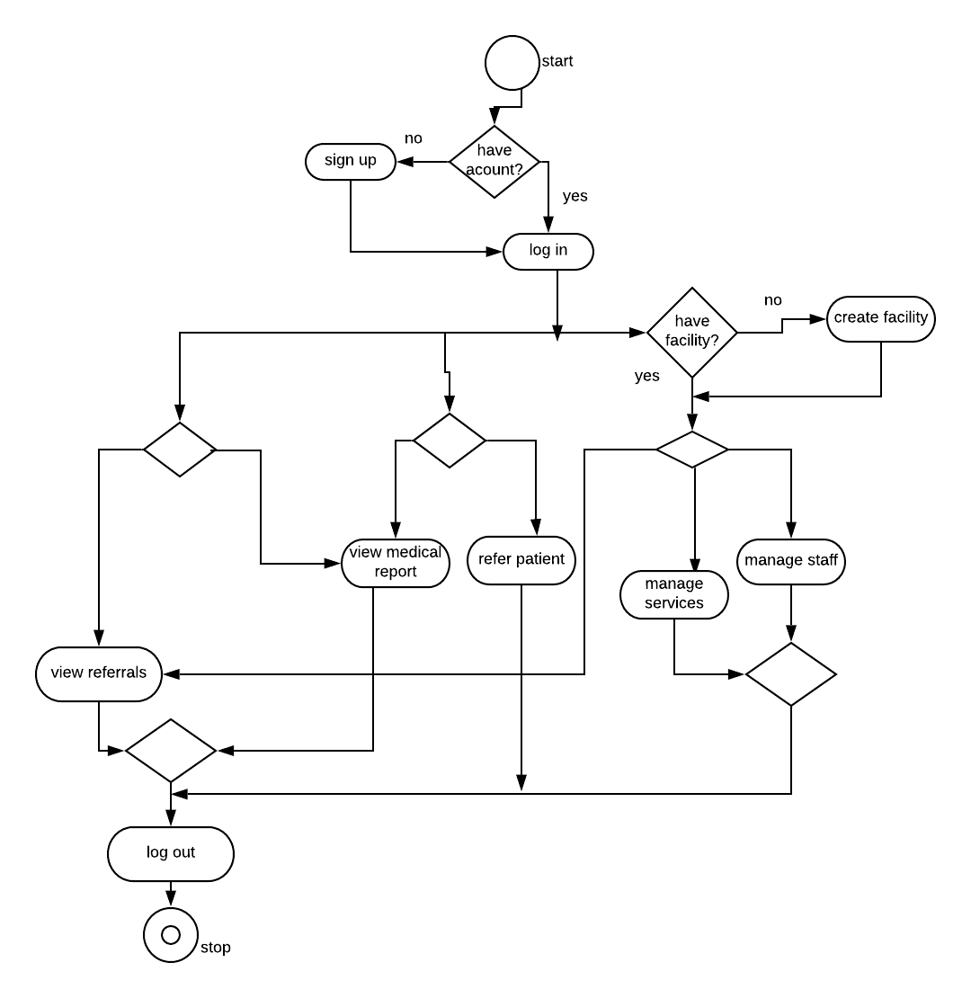

Structure charts
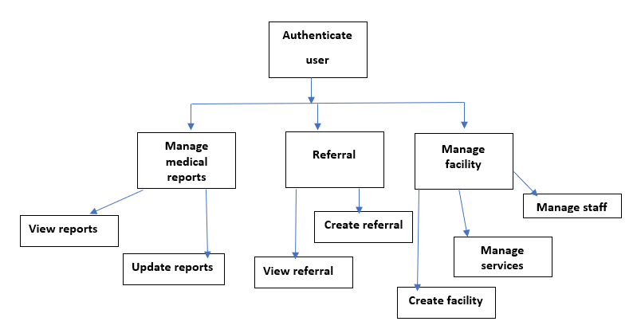

Internal Communications Detailed Design
The system will implement client-server architectures, this means the client PCs will communicate to the server using HTTP protocol port 80. Since there is also a database which will be storing data for the system, the server will connect to the database using port 3306

EXTERNAL INTERFACES
HRM is a standalone application that do not rely on any external systems. Its data is purely user generated and it is being used by the users currently registered with the system.

SYSTEM INTEGRITY CONTROLS
- Authorization Control
Every user is authenticated at the log in stage before accessing the respective resources of the system. It involves the password matching between the one stored in the database and the one the user inputs.
- Password Encryption
All password will be encrypted before they are stored in the database through hashing.
- Data validation
Before data is stored in the database, it will be validated to ensure only expected data is stored e.g. email addresses.
- Database Restriction
Users are limited to update data that they are supplied. Access of data affecting the whole system will be restricted unless it is the system administrator or the database administrator.
- Integrity control
This will ensure that data stored in the database cannot be violated or altered by any unauthorized parties.
- Confidentiality Control
Only users can view their own data e.g. the patient should view his/her own referral and medical report data. This will ensure that unauthorized access of personal information will be prohibited.

